BID SPECIFICATION
Product Name: CN-Whole Grain Corn Dog Nuggets Date: May 11, 2015
Whole Grain Batter Wrapped Chicken Franks
Meets Whole Grain Requirements for Child
Product Code: 20452 Nutritional

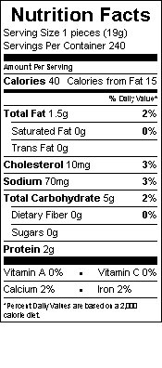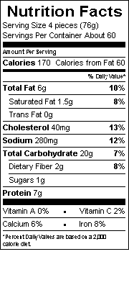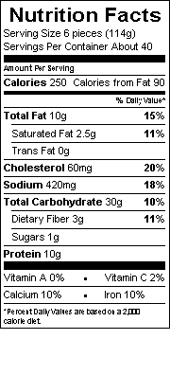
Description:
Fully cooked, whole grain batter-wrapped chicken franks. Product is bite-sized chicken corn dog nugget individually quick frozen to lock in freshness and extend shelf life. Product is sold and distributed frozen.
Ingredients:
Mechanically Separated Chicken, Water, Salt, Corn Syrup Solids, Flavorings, Dextrose, Ascorbic Acid (Vitamin C), Garlic Powder, Natural Smoke Flavoring, Extractive of Paprika, Sodium Nitrite.
Battered And Breaded With:
Water, Enriched Whole Grain Wheat Flour (Enriched With Niacin, Reduced Iron, Thiamine Monoitrate, Riboflavin, Folic Acid), Enriched Corn Meal And Corn Flour (Both Enriched With Niacin, Reduced Iron, Thiamine Monoitrate, Riboflavin, Folic Acid), Sugar, Soy Flour, Modified Corn Starch, Salt, Leavening (Sodium Acid Pyrophosphate, Sodium Bicarbonate), Nonfat Dry Milk, Egg Yolks, Dextrose, Sodium Caseinate.

Case Specifications: Allergens: Wheat, Diary, Soy, Eggs Shelf Life: Excess of 12 Months When Frozen
Case Weight: 10 lbs
Case Pack: Approx. 240 Count per Case- 2/5 Lb. Bags
Case Cube: .43
Case Dimensions: 14 ¼ X 10 X 5 ¼
087140
SIX .67 OZ. FULLY COOKED, WHOLE GRAIN BATTER
WRAPPED CHICKEN FRANKS PROVIDED 2.00 OZ.
EQUIVALENT MEAT AND 2.00 OZ EQUIVALENT GRAINS
FOR CHILD NUTRITION MEAT PATTERN REQUIREMENTS.
(USE OF THIS LOGO AND STATEMENT AUTHORIZED
BY THE FOOD AND NUTRITION SERVICE. USDA 5/13.)

CN
Pallet Configuration 10 X 12
Case per Pallet 120

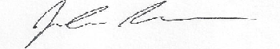
I certify that the above product information is accurate
CN
CN

___________________________________________
Signature/Title
CN

