**Nudges and Nudge Interventions**

Nudges and Nudge Interventions

section OVERVIEW

**In this section we will cover:**

* What are Nudges?
* The Power of Nudges (video link)
* The Goals of Nudges at Foodbanks and Food Pantries
* Nudges in Action

**WHAT ARE NUDGES?**

Nudges and Nudge Interventions

Nudges, as a concept in behavioral science and economics, as defined by David Just PhD of Cornell University, are small environmental cues or changes in one’s environment that can make an impact on food choices and ultimately health. Nudges are meant to be “low cost, non-invasive and easy to implement nutrition education strategies to help food banks and pantries increase the nutritional value of the foods their clients are receiving”.

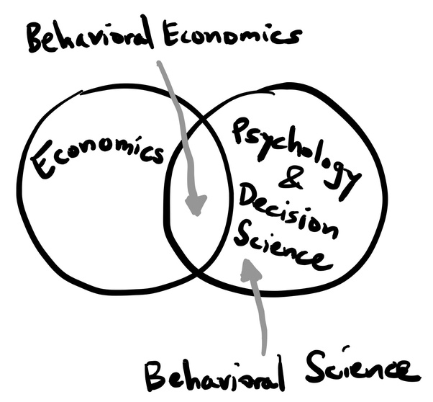

**THE POWER OF NUDGES – COURTESY OF FEEDING AMERICA (VIDEO LINK)**

**Nutrition and Health Strategies “Nudges” | Feeding America**

A video posted by Feeding America highlighting evidence based nutrition education strategies to encourage the consumption of healthy foods across Feeding America’s nationwide network of foodbanks and food pantries. With the help of Cornell University’s behavioral economics department, the video introduces the concept of “nudges”.



Access video here <https://youtu.be/9HayxGU6KBs> or by scanning QR code

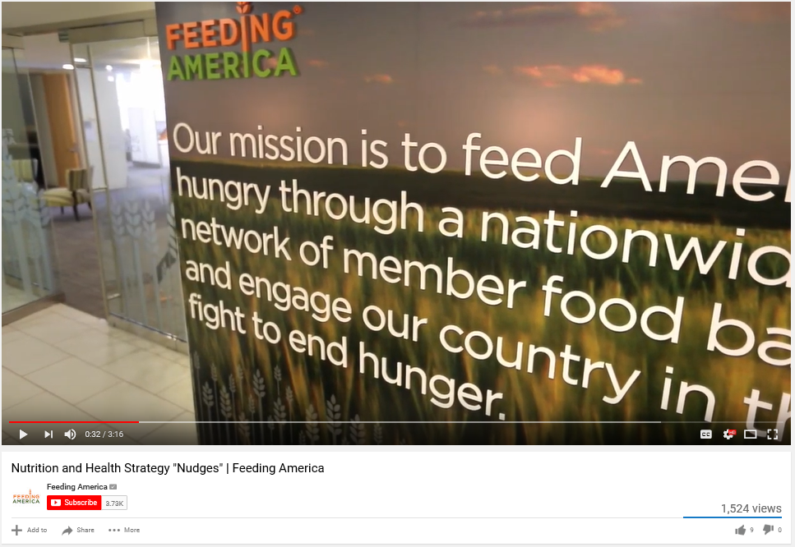

**THE GOALS OF NUDGES AT FOOD BANKS AND FOOD PANTRIES**

Nudges and Nudge Interventions

1. To make produce displays easily seen, stand out and the focal point of your food pantry.
2. To make fresh fruits and vegetables easier to access and more convenient.
3. To increase the availability and variety of fresh fruits and vegetables being offered, by improving purchasing and storage options.
4. To provide frequent and intentional reminders of healthier options.
5. To encourage pantry guests to try new foods and to expect positive experiences with trying new foods.

Remember, there is no one perfect method for implementing nutrition education or nudge interventions across all foodbanks and food pantries.

# NUDGE GOAL #1 – To make produce displays easily seen, stand out and the focal point of your food pantry

Nudges and Nudge Interventions

*Research suggests: making fruits and vegetables more prominent and highly visible will increase their consumption.*

## Nudge Applications

1. Create attractive and well organized displays. Displays should be well lit.
2. Make displays highly visible, centrally located and easy to get to. Research conducted by Just and Wansink, found a 100% increase in produce selection when placed in a prominent location.
3. Place products you want to promote at eye level.
4. Create “natural” displays by incorporating a typical farmer’s market displays.

Nudges and Nudge Interventions

1. Display produce in clean and attractive bowls (transparent or non-transparent), baskets or free standing containers.
2. Messages are more effective when repeated. Place produce displays in more than one location to increase the frequency of exposure.
3. Display produce in such a way that it appears abundant and plentiful.

Nudges and Nudge Interventions

1. Improve the presentation of fresh produce displays by implementing a system of cleaning, sorting and discarding spoiled produce prior to displaying them.

# Nudge Goal #2 - To make fresh fruits and vegetables easier to access and more convenient

*Research suggests: consumption of fresh fruits and vegetables are likely to increase when these items are easily accessible, convenient and readily available.*

## Nudge Applications

1. Get creative with distribution days and times. Try scheduling a distribution in conjunction with a social event (dinner, meeting, class, etc.).
2. Pre-bag fruits and vegetables by pounds per household, pounds per person, serving size per household, etc.
3. Bag loose snack items into convenient grab and go snack bag varieties.

Nudges and Nudge Interventions

1. Display together, items that can be combined into a meal. Things such as oatmeal or cereal and fresh fruits; pasta, sauce and fresh vegetables; chicken or beef broth, fresh vegetables and meats. Include signage illustrating how items can be easily incorporated into a complete meal. Provide simple and easy to follow recipe cards.

**+ + =**

**Chili Beans Diced Tomatoes Ground Meat Chili (add  
 (w/green chilies optional) desired toppings)**

# Nudge Goal #3 - To increase the availability and variety of fresh fruits and vegetables being offered, by improving purchasing and storage options

Nudges and Nudge Interventions

*Research suggests: people will consume more fruits and vegetables if they have more options to pick from.*

## Nudge Applications

1. Increase the volume of fruits and vegetables distributed at your food bank or food pantry.
2. Provide multiple fruit and/or vegetable options at each distribution. Introduce your clients to new fruits and vegetables by adding one or two new items at each distribution.
3. Offer a variety of fresh, frozen and canned fruit and vegetable options.

Nudges and Nudge Interventions

1. Create new systems of acquiring fruits and vegetables (gleaning, farmer donations, multiple produce pick-ups/deliveries from the Foodbank, food rescue, growing your own produce, etc.
2. Ensure adequate storage of produce, root vegetables and winter crops. Incorporate glass front refrigerators.

# Nudge Goal #4 - To provide frequent and intentional reminders of healthier options

Nudges and Nudge Interventions

Research suggests: people need to be reminded of healthful eating “at just the right time”.

## Nudge Applications

1. Place emphasis on the foods you want to encourage by placing recipe cards next to these items. Situate all recipe ingredients (and the recipe) in close proximity to one another.
2. Incorporate visual cues by labeling items that are “locally grown”, “fresh”, “organic”, “natural”, etc.
3. Highlight *Foods to Encourage* in specific locations of your food bank or food pantry; waiting areas, hallways, shopping carts, walkways, etc. Use vibrant printed material to promote fresh fruits, vegetables and other foods you want to encourage.

Nudges and Nudge Interventions

1. Utilize the personal relationships you and your staff or volunteers ay have with the clients you serve. Simple words of encouragement, a conversation about an item, a recommendation, etc. can have a positive influence on food choice.
2. Display a daily, weekly or monthly “specialty item” and provide recipes, facts or tips detailing what the item is, how it’s grown, how to prepare, seasonings to enhance flavor, etc.
3. Incorporate the use of arrows, placed on either the floor or hanging overhead, directing clients to the foods you want to encourage.
4. Identify healthier options with visual cues such as shelf tags, labels, color code system or symbol system.

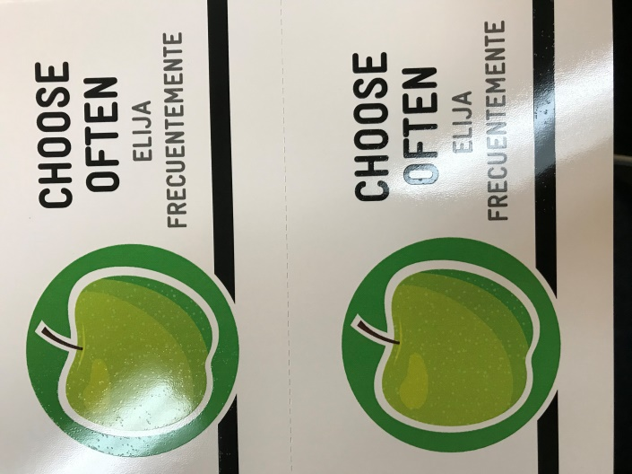 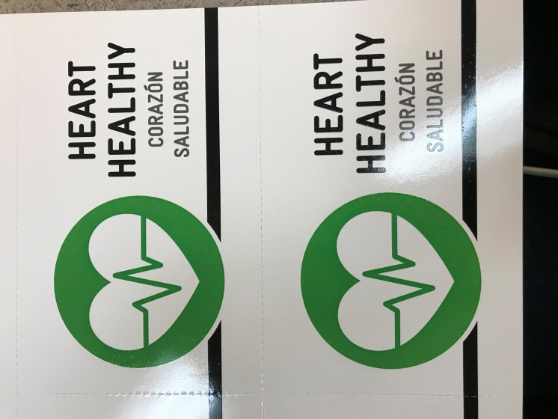

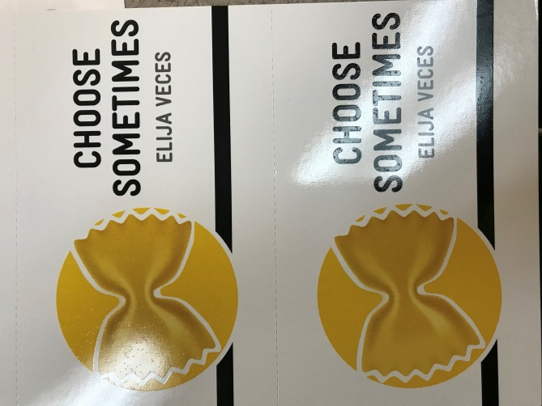 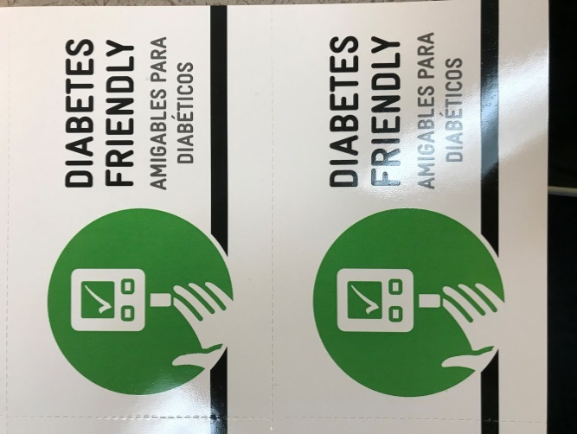

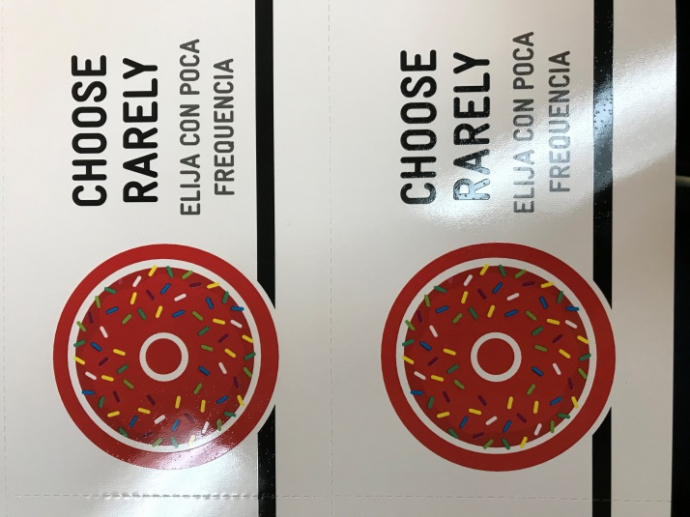

1. Normalize behavior by suggesting an amount for your clients to take based on household size. Include signage as positive reinforcement that encourages the client’s choice being a healthy and positive choice.

Nudges and Nudge Interventions

# Nudge Goal #5 – To encourage pantry guests to try new foods and to expect positive experiences with trying new foods

*Research suggests: people need multiple opportunities to sample new food(s) before they establish a preference for an unfamiliar food(s).* Flavor is 90% smell and 10% how it actually tastes.

## Nudge Applications

* + 1. Provide taste tests/sample and cooking demonstrations. When facilitating taste tests, introduce new flavors with currently liked flavors.
    2. Appeal to as many senses as possible. Incorporate color (fruits, vegetables, herbs, etc.), smell (sautéing onions, using fresh herbs, etc), taste (the food should taste good), texture, etc.
    3. Presentation is everything. All items involved with the food sampling experience should be neat, clean and attractive (table cloths, bowls, plates, etc.).

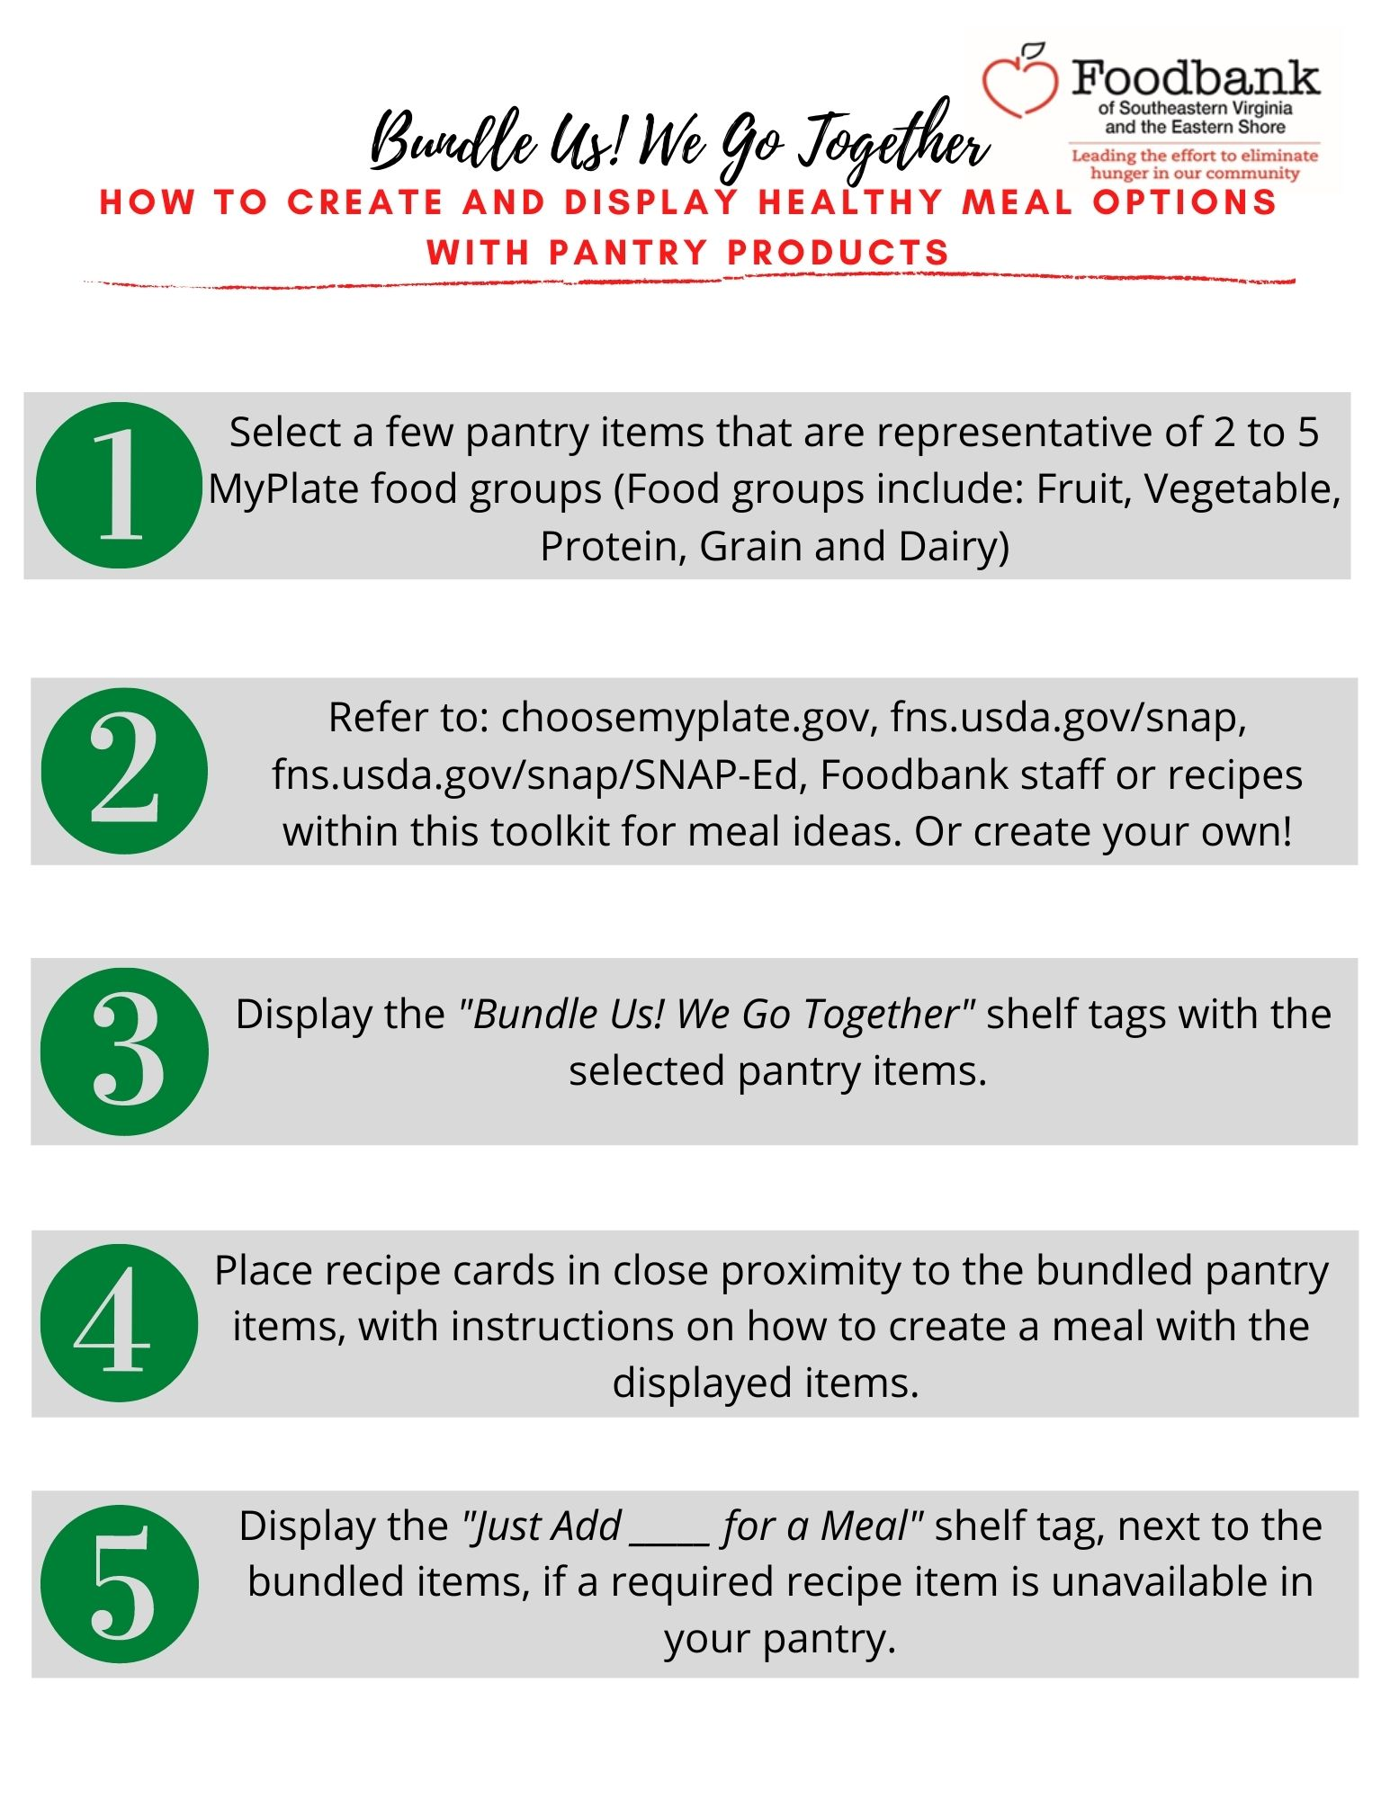

**Bundle Us!**

**We Go Together**

**Bundle Us!**

**We Go Together**

**Bundle Us!**

**We Go Together**

Baked zucchini boats topped with tomato & Cheese

Creamy pumpkin pasta; spinach, sausage and mushrooms optional

Chili; top with sour cream, jalapenos, cheese, etc

Oatmeal topped with fruit; top with any fruit

Grits with spinach and skillet cooked egg

Lentil and vegetable soup; optional add ins: diced turkey, butter nut squash

Grilled chicken, brown rice & vegetable soup

Burrito bowl; top with: Romaine, Mexican corn, salsa, etc.

Tuna noodle casserole

Quesadilla; other filling options: chicken, corn, spinach, roasted peppers, etc.

